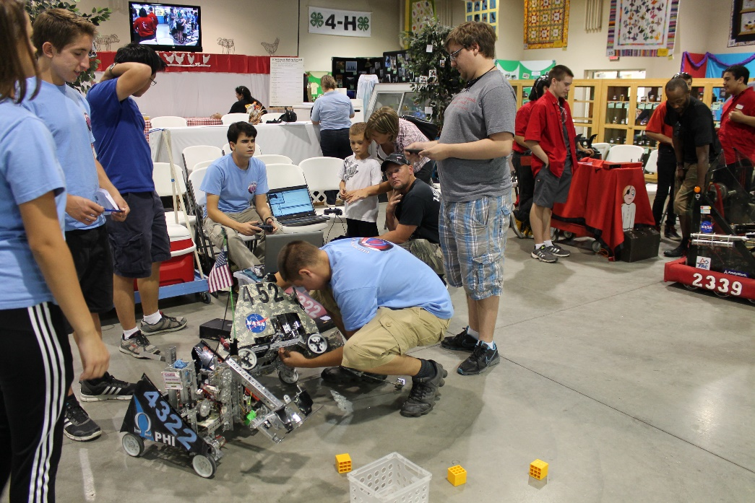
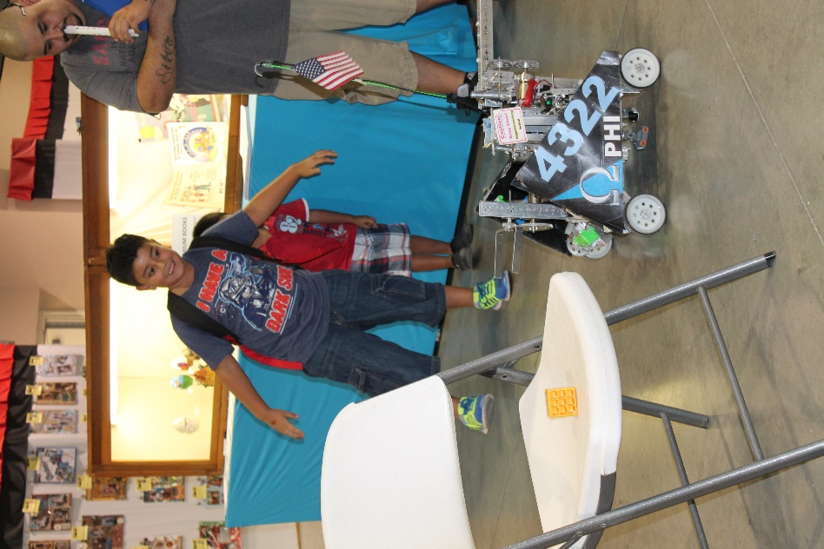
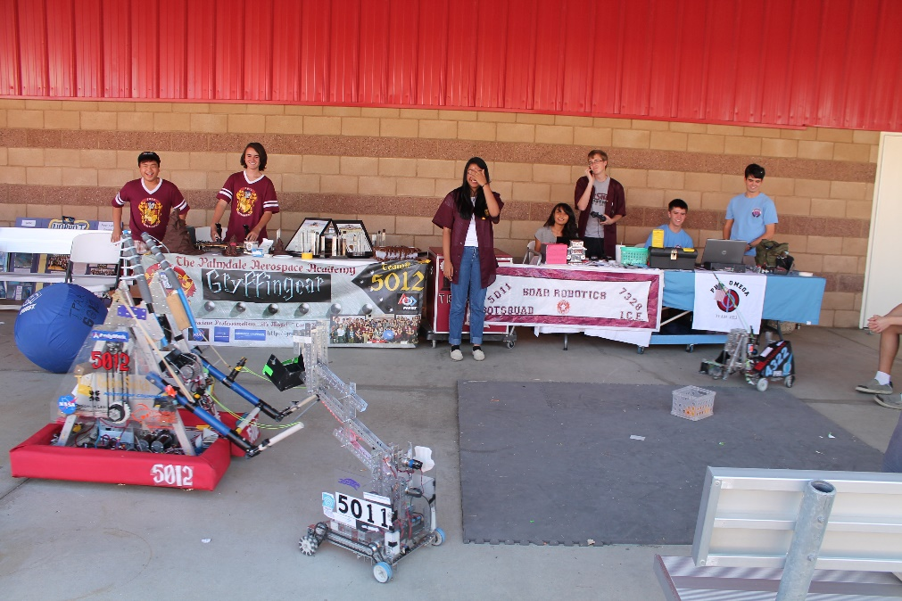
PHI Robotics, a 501(c)(3) nonprofit organization, is the greater umbrella over both our team and our sister team PHI Alpha. Since we operate as one team, we share sponsors, funds, and a budget.

FUNDRAISING

PHI is sponsored by corporations, private individuals, and our own fundraising events. Our corporate sponsors are Lockheed Martin, NASA, and Northrop Grumman. Lockheed Martin has generously given us funds, and NASA buys us parts and machines custom parts for us. Northrop Grumman also gives us funds. Our fundraising events have included everything from demonstrating our robots at restaurant events, selling Yankee candles, and hosting garage sales.
We seek to use our money wisely, which includes using it to help other teams. We fund two local FIRST LEGO League teams, and help fund another FTC team. In previous years we have also used our funds to host qualifying tournaments for the LA region.
